**Project Title**

Students Control Mobile Application

**Developed By:**

1. Keo Yinyong B20223600

2. Sous Naseu B20221460

3. Taing Khimsonita B20222067

4. Kun Kimhorng B20221472

5. Roem Hea B20221638

**Table of Content**

**Page**

1. Project Description 3

2. List of Important Requirements or Features 3

3. Project Architecture 3

4. Project Methodology 4

5. Tools and Technologies 4

6. Project UI Design 4

7. Quality Control and Testing 6

8. Communication 6

9. Project Development Difficulties 6

10. Lesson Learned 6

11. Conclusion 7

Conclusion

# Project Description

This project is called Students Control Mobile Application. It is an android mobile application that allows Students to note about lessons for every day and every time. In Notes, we have the Title Content so students can easily use this app. This project is done by using Java Programming Language.

# List of Important Requirements or Features

* Create new user account (User register)
* User login with email and Password
* User can control the account(logout View Update and Delete)
* User can browse history Noted
* User can add new Note
* User can view update or delete Note

# Project Architecture

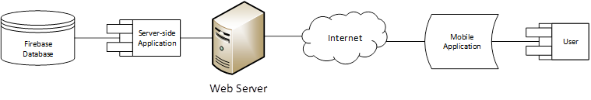



# Project Methodology

We have 6 steps to develop in this project. In the first step, we discuss how we do this project. Second step, we list down important Requirements or Features. Third step, we draw about the architecture plan. Fourth step, we prepare for the project Methodology. Fifth step, we list down Tools and Technologies for creating this project and the last step, we design UI and coding for our project.

# Tools and Technologies

* Java Programming Language
* SDK (version 34)
* Android Studio IDE (version 2023.1.1)
* Firebase Database (version 20.3.1)
* Firebase Authentication (version 22.3.1)
* Google Service (version 4.4.0)
* Android Material Design (version 1.5.0)
* Figma UI Design
* Drawio Drawdiagram
* Git
* Github

# Project UI Design

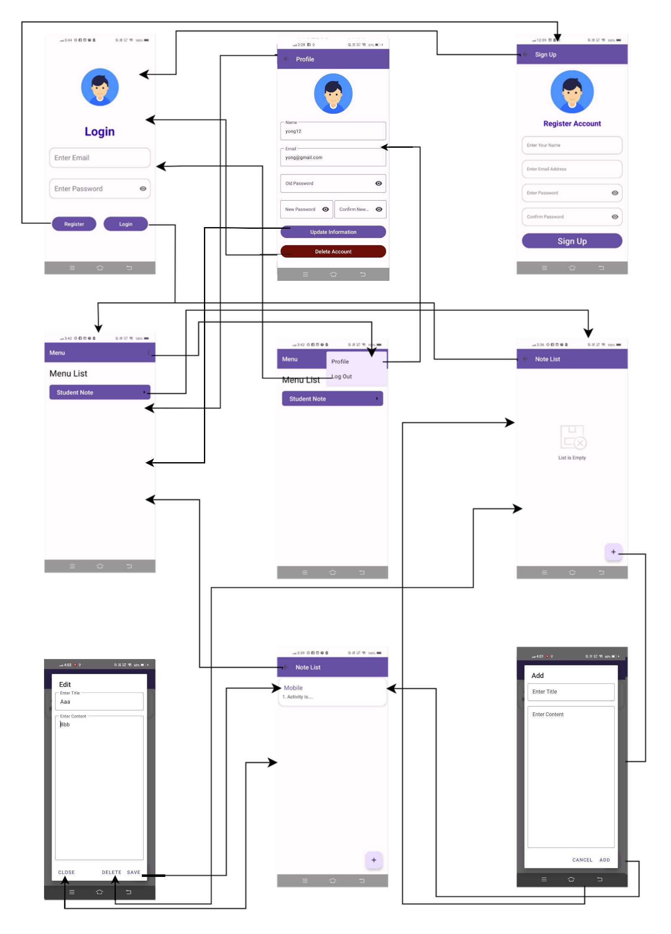

# Quality Control and Testing

This project can only implement functional testing to test if the requirements and features work perfectly. Due to time constraint, we cannot implement performance testing and usability testing for this project.

# Communication

Our team has ensured good communication throughout the entire project duration. We have arranged to meet and discuss the project 2-3 times during the development of this project. We also meet on a daily basis during our class time to have some additional discussion and questions.

# Project Development Difficulties

Throughout the entire duration of this project development, there are some difficulties that we have encounter. First, as the project is working Figma UI design, there are some difficulties in drawing diagram processing because it is our first time as using Figma as first project. There is also difficulty with integrating our code together as we divide separate feature to do individually.

# Lesson Learned

From the development of this project, we learned a lot of new things and experiences such as knowing how to use Figma UI design, Android Material design and Firebase Database, having good communication with team members and make us understand about building project and how it’s processing.

# Conclusion

To sum up, Student Note Mobile Application is an application that allow has been a testament to innovation, collaboration, and the transformative power of technology in the realm of education. As we draw the curtains on this phase of the project, several pivotal learnings and accomplishments spring forth, paving the way for a brighter and more efficient learning experience.